SHORT MANUAL OF SPORT CENTRE SYSTEM

**Before running the program:**

1. Please create a new database in phpadmin with name 'sportcentre' and import the sql file named ' sportcentre'.  
     
   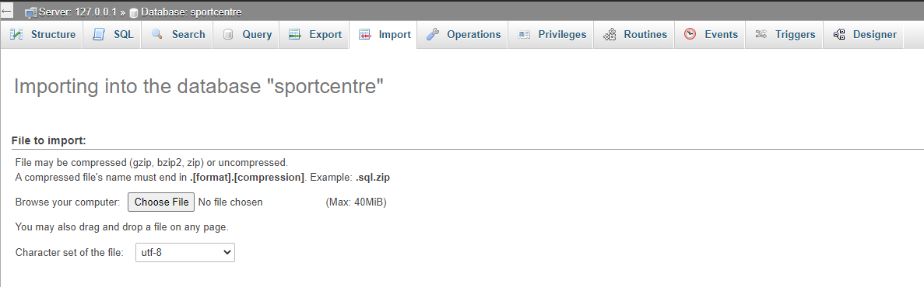
2. Next run the system on NetBean and make sure the XAMPP (Apache and MySQL) has started.

**During running the program:**

1. As soon as the program has been run, it will begin with the login interface. Two type of user can login the system which is admin and customer. 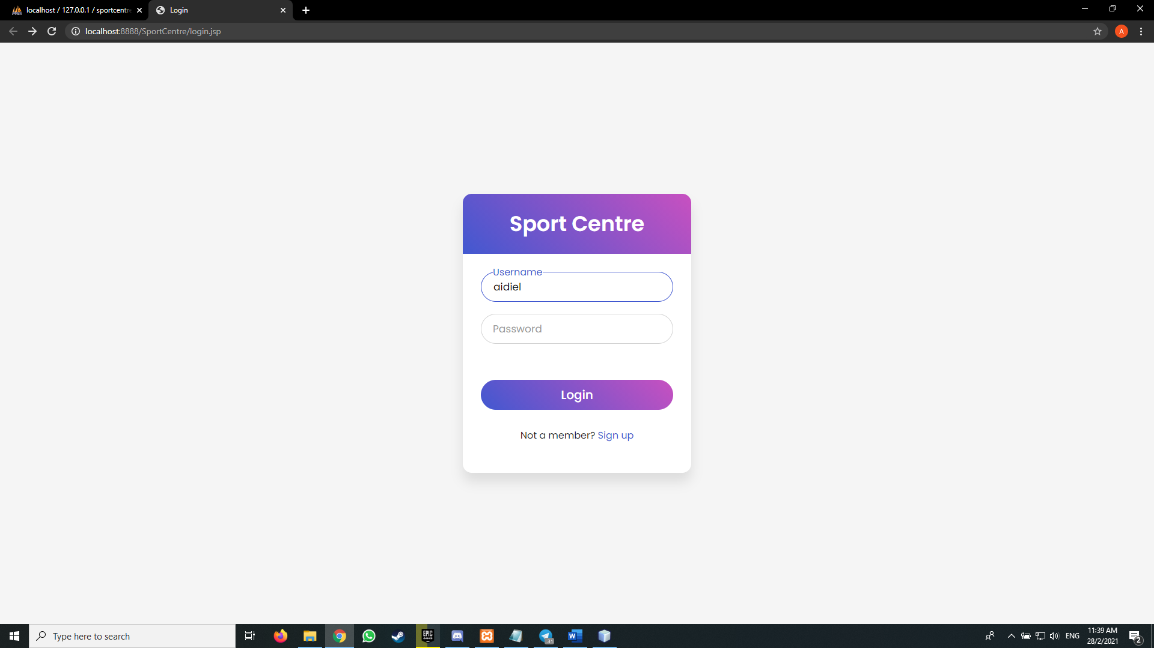
2. For customer, you can use the existed customer in the database or register as a new customer.

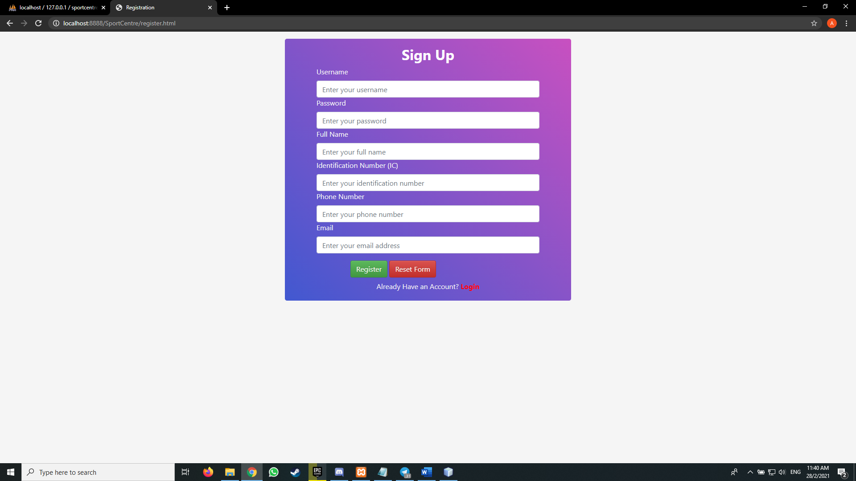

1. For admin, the username is admin and the password is 123456.

**Customer side:**

1. After successfully login, customer will be directed to homepage.

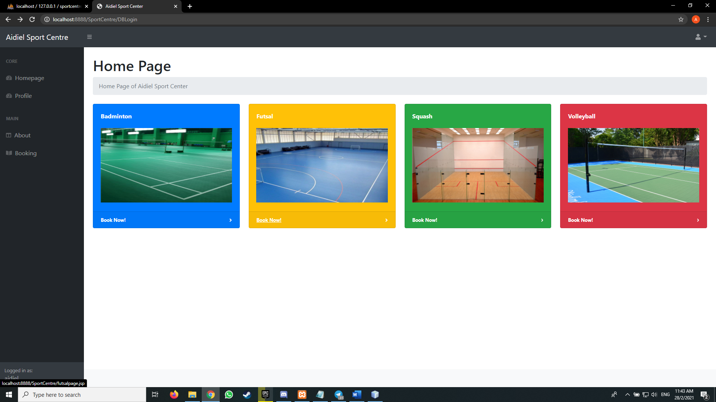

1. Here, customer can choose to book any kind of courts. The details of the court will be displayed when the customer try to check alongside with their availability.

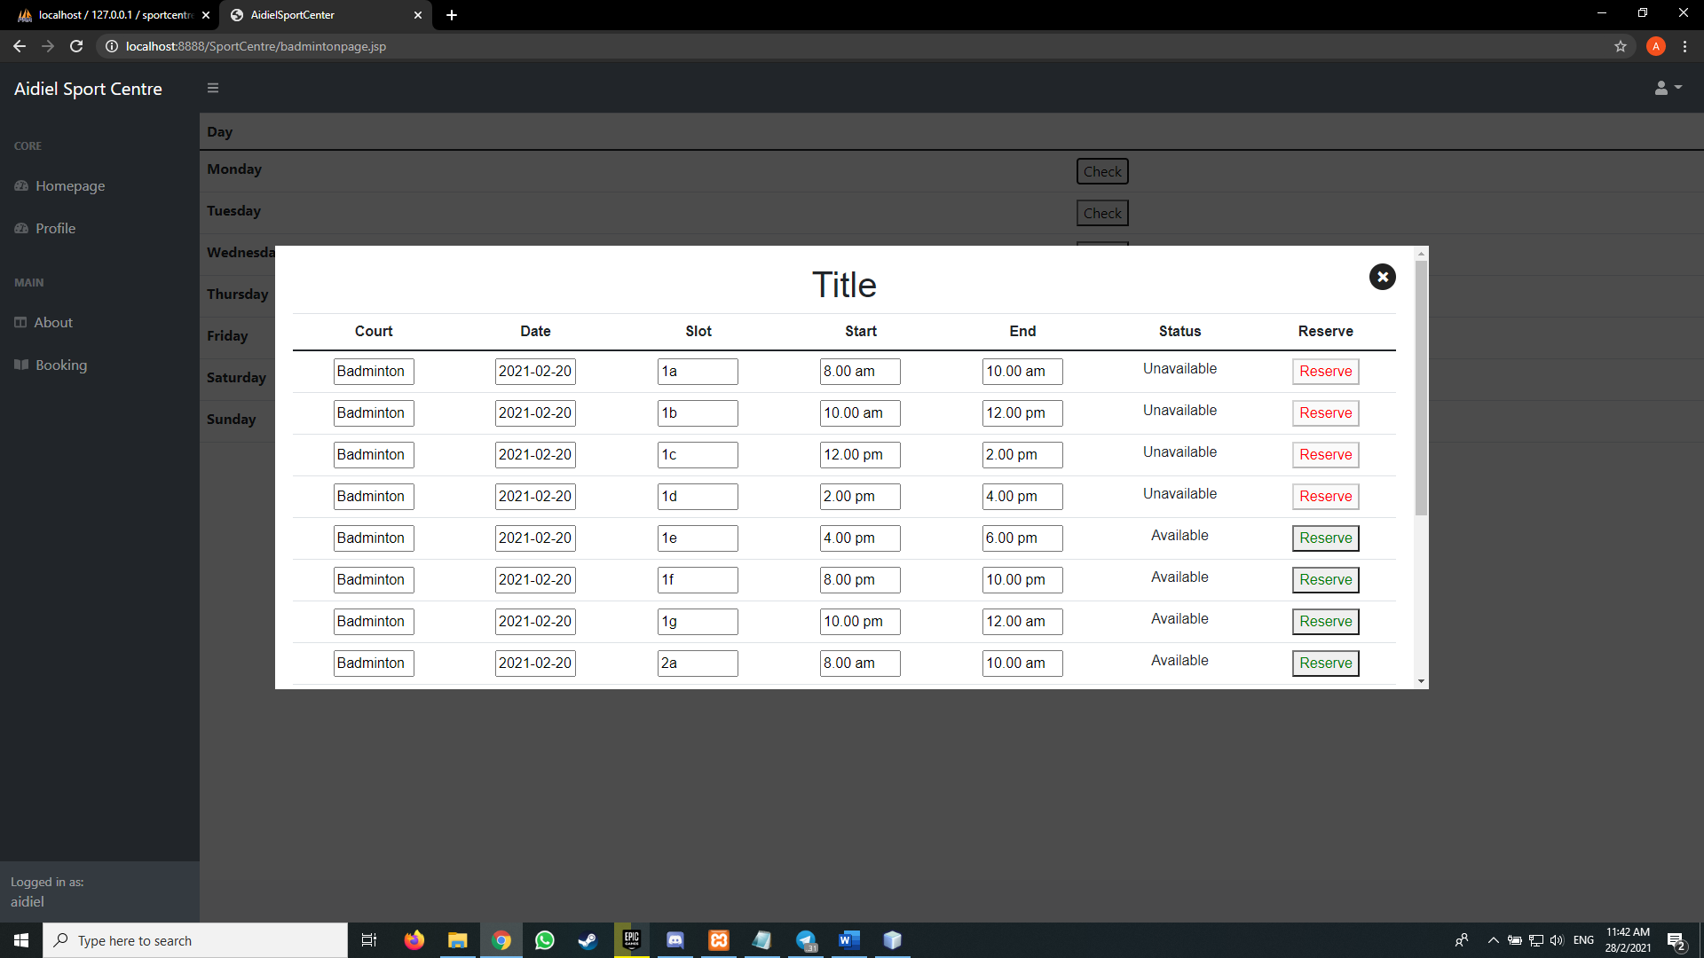

1. After the court has been chosen, the customer need to fill the booking form. 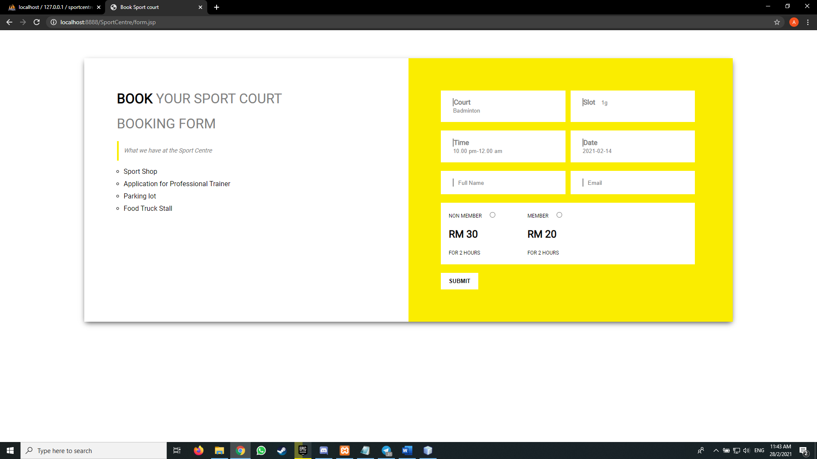
2. Next, there is Profile page where user can check their details and could make amendment here.  
   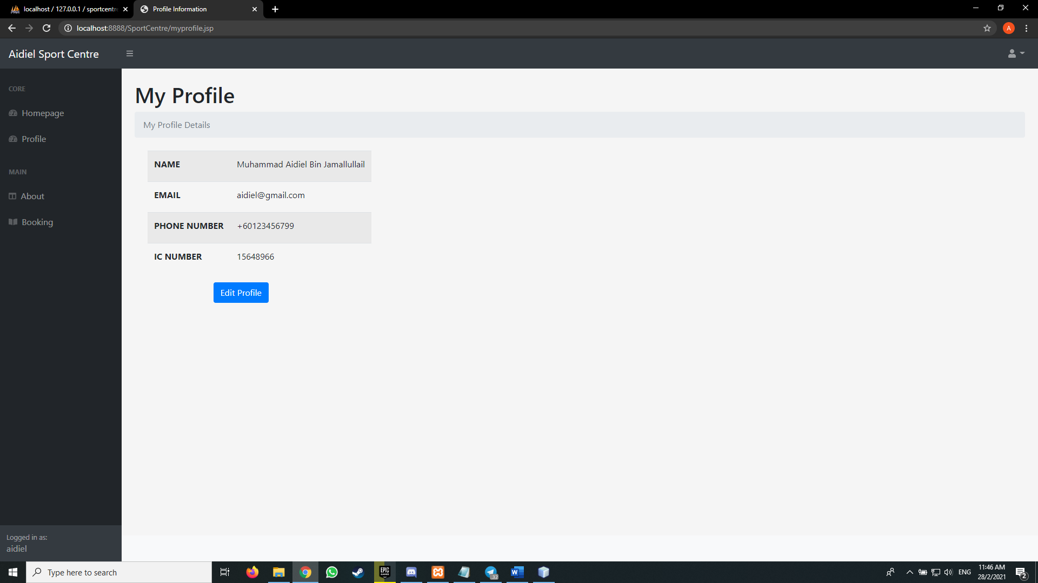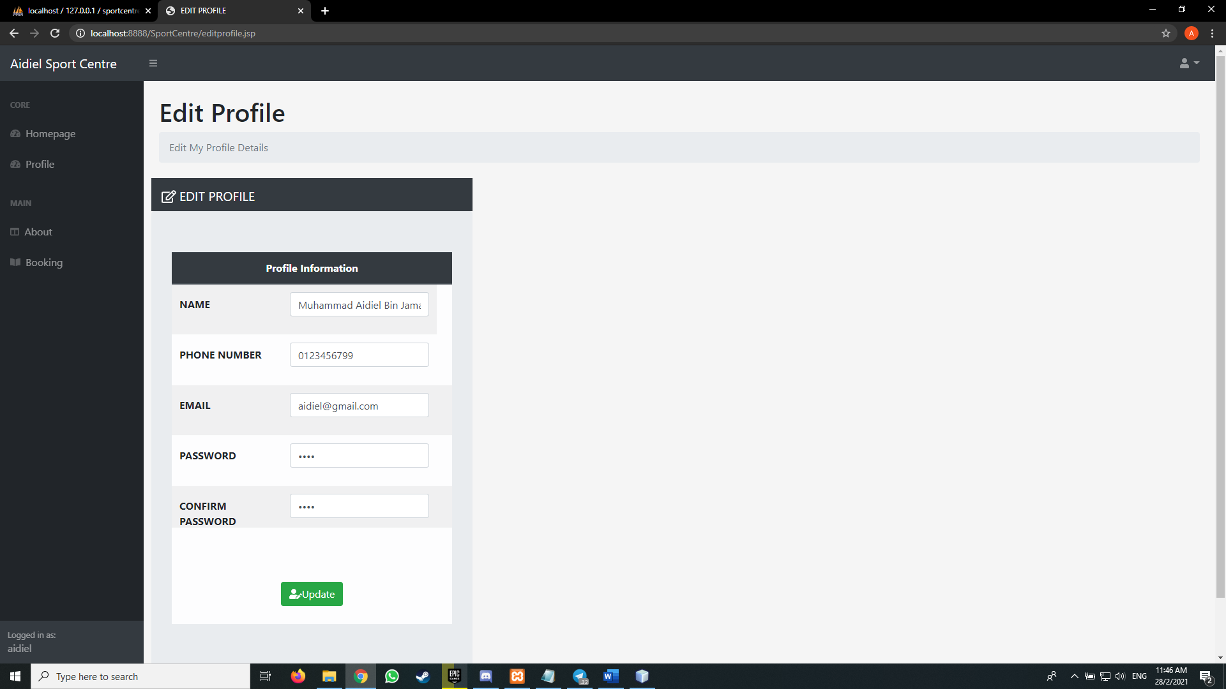
3. There is also About page to see little info about the Sport Centre and My Booking page so that the customer can see their booking.
4. Whenever the customer wants to end the session, they can simply click the logout button on the upper right corner.

**Admin side:**

1. For admin, there are two major functions which are Set Date and Manage Booking.
2. The purpose of Set Date is to set a new date every week so that a new booking from customer can be made in the future.

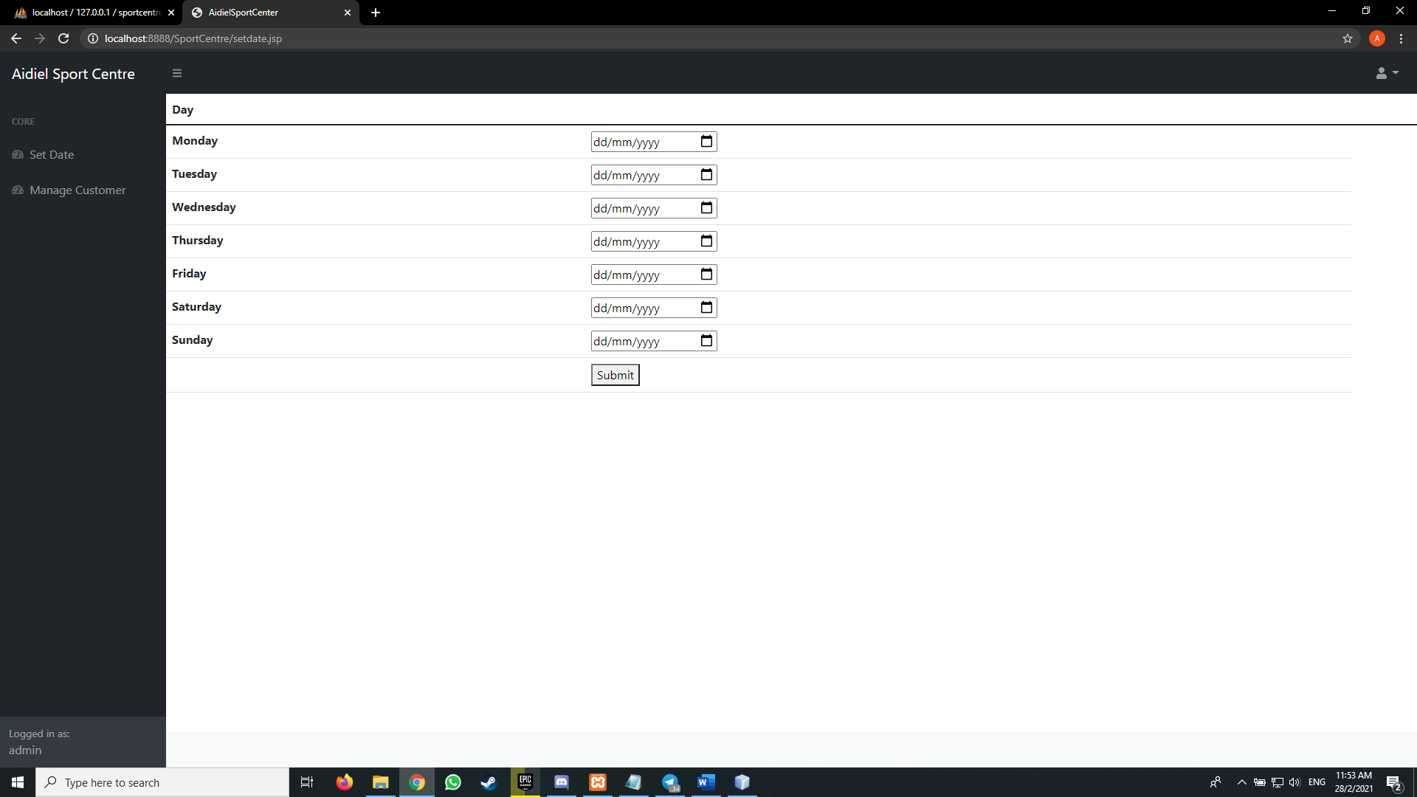

1. Meanwhile for Manage Booking, admin can view all of the booking made from a certain customer when the username of that user is entered. 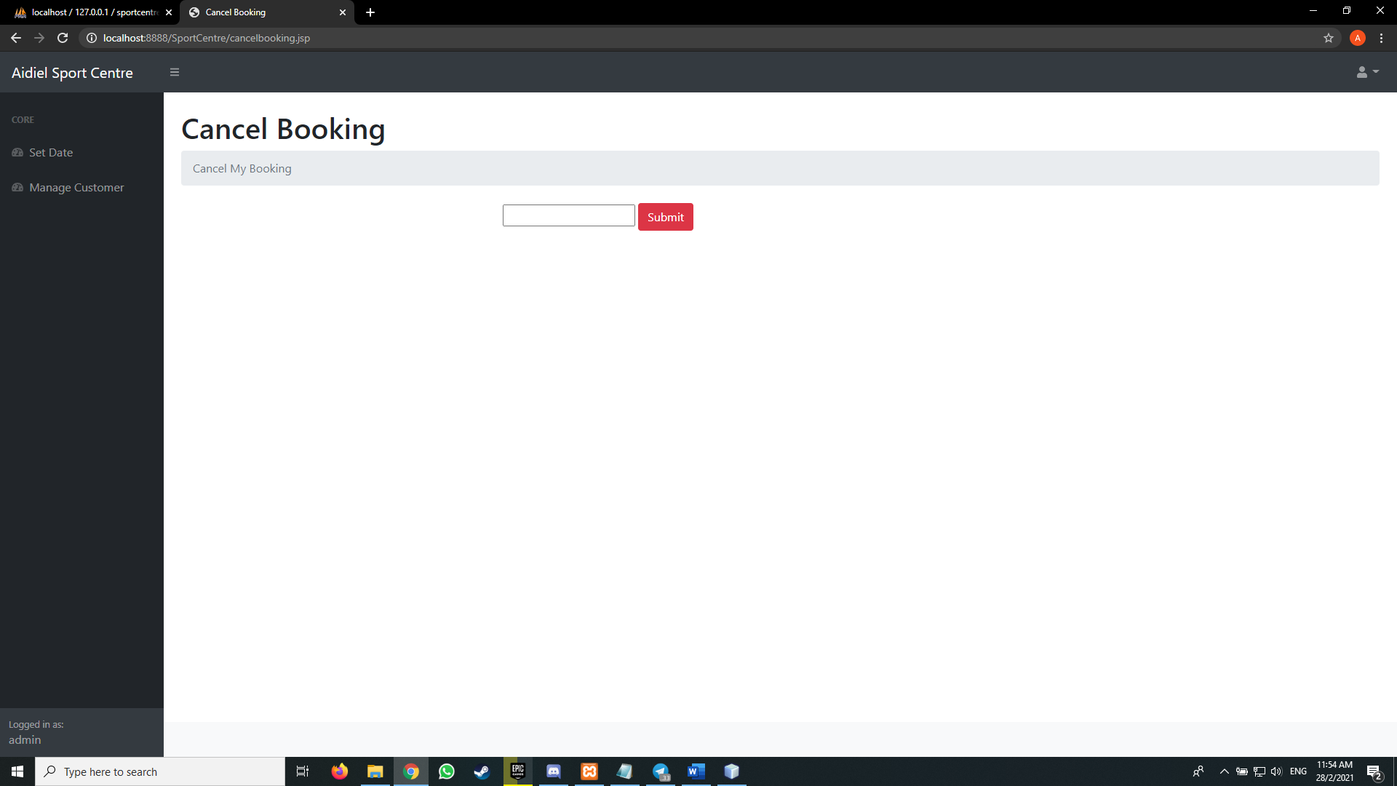
2. The list of the booking will be displayed. Admin can mark the customer presence as soon as they showed up. Admin also can cancel their booking if needed.

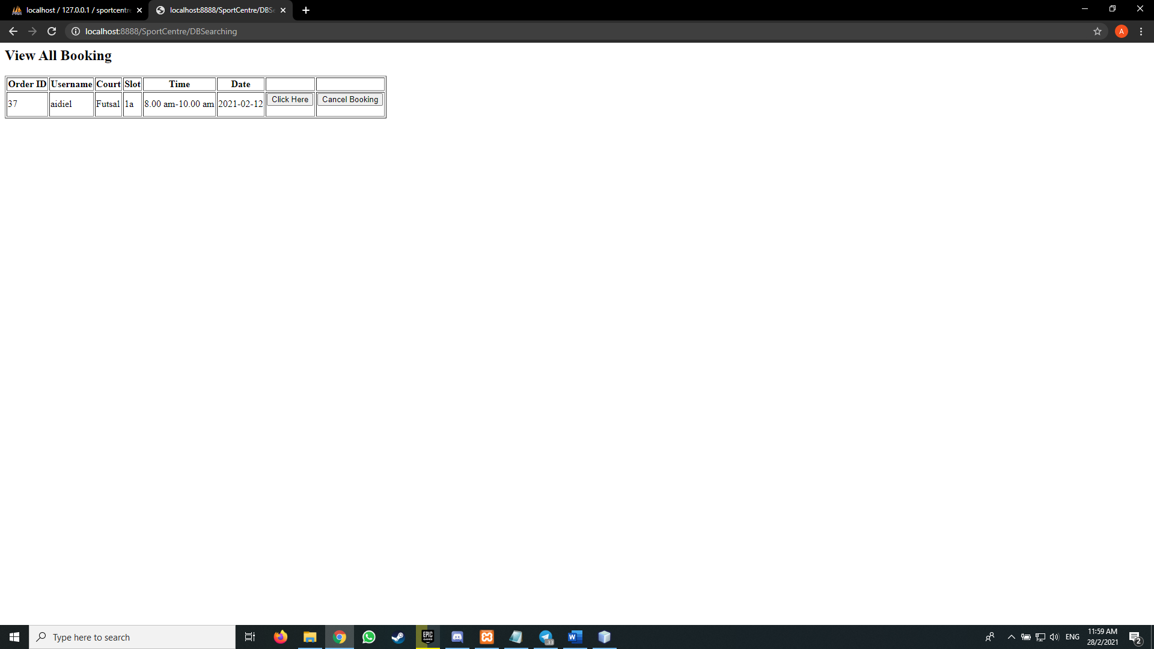

1. Same goes for admin, they can logout by clicking the logout button on the upper right corner.